**Project Design Phase-II**

**Technology Stack (Architecture & Stack)**

|  |  |
| --- | --- |
| Date | 15October 2022 |
| Team ID | PNT2022TMID37457 |
| Project Name | Project –Smart Farmer-IoT enabled smart farming application. |
| Maximum Marks | 4 Marks |

**Technical Architecture:**

The Deliverable shall include the architectural diagram as below and the information as per the table1 & table 2

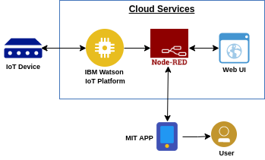

**Table-1 :Components & Technologies:**

|  |  |  |  |
| --- | --- | --- | --- |
| **S.No** | **Component** | **Description** | **Technology** |
|  | User Interface | How user interacts with application e.g.  Web UI, Mobile App, Chatbot etc. | MIT app |
|  | Application Logic-1 | Logic for a process in the application | Node red/IBM Watson/MIT app |
|  | Application Logic-2 | Logic for a process in the application | Node red/IBM Watson/MIT app |
|  | Application Logic-3 | Logic for a process in the application | Node red/IBM Watson/MIT app |
|  | Database | Data Type, Configurations etc. | MySQL, NoSQL, etc. |
|  | Cloud Database | Database Service on Cloud | IBM cloud. |
|  | Temperature sensor | Monitors the temperature of the crop |  |
|  | Humidity sensor | Monitors the humidity |  |
|  | Soil moisture sensor (Tensiometers) | Monitors the soil temperature |  |
|  | Weather sensor | Monitors the weather | . |
|  | Solar panel |  | . |
|  | RTC module | Date and time configuration |  |
|  | Relay | To get the soil moisture data |  |

**Table-2: Application Characteristics:**

| **S.No** | **Characteristics** | **Description** | **Technology** |
| --- | --- | --- | --- |
|  | Open-Source Frameworks | MIT app,Node-Red | Software |
|  | Scalable Architecture | Drone technology, pesticide monitoring ,Mineral identification in soil | Hardware |